

BFS Complete Concrete Pipe Plant 2003

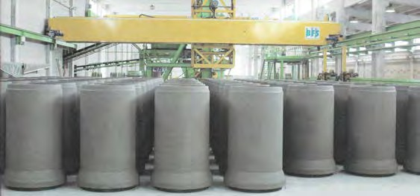The plant consists of two production lines, one fully automatic for pipes up to DN 1200 (1.20m/ 48”), and one semi-automatic for pipes up to DN 3600 (3.60m/ 12ft), box culvert etc.

**HIGH VOLUME PRODUCTION OF PIPES WITH HIGH QUALITY**

**AND LOW MANPOWER REQUIREMENTS**

**The automatic plant from 12“/300mm to 48”/1200mm** is based on a packerhead machine from BFS. The automatic handling is an open floor system. The plant design, layout, the automatic open floor system, and commissioning have all been provided by us. The packerhead machine has our control software and electronics.

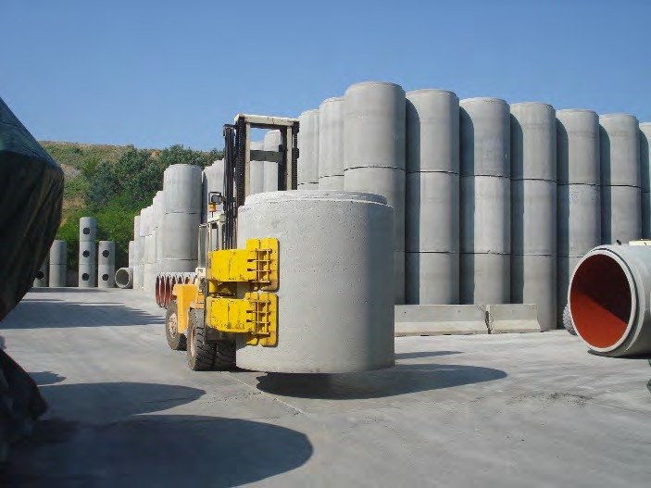The machine can produce 42 pipe/hour up to 15”/380mm and about 200 48”/1200mm pipes in one shift.

Pipes are 8 ft/2500mm tall.

**The vibration machine** is a double station, one with core vibration, and one with a vibration table.

The machine is equipped with molds for round pipe, box culverts, and manholes. The offer is complete including 2 steel cage machines, 5 forklifts, a tilter for box culvert, 2 robotic pipe handlers, one overhead crane, and a batching plant.



**FULLY AUTOMATED PLANT DN 300 (12’’) – DN 1200 (48’’)**

**SEMI AUTOMATED PLANT UP TO DN 3600 (12ft)**

**& BOX CULVERT**

**BATCHING PLANT**

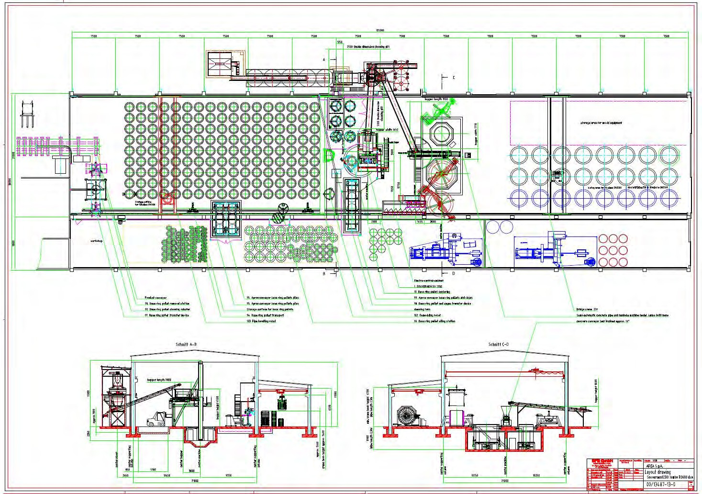

**BFS SOUVERAEN BFS JUMBO**



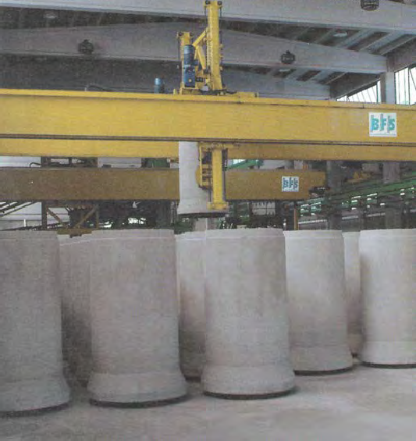

## LOCATION AND CURRENT CONDITIONS

The plant is located in Italy, it is in good condition and well maintained.

It was built in 2003 but has low hours, since it has worked very little since 2018.

It is not currently running.

## OTHER CHARACTERISTICS

It will be advantageous for a Buyer to utilize the same fundamental layout to minimize the costs associated with modifying parts of the process.

## SERVICES PROVIDED

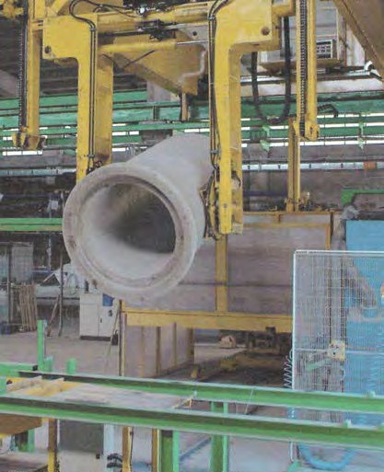We can provide complete assistance from disassembly to commissioning. We can also provide services related to controls upgrades if necessary.

## PRODUCTION PROCESS AND MANPOWER

BSF Automated Packerhead requires 2 persons for the whole plant, 1 for the cage machine, 1 for the tip out.

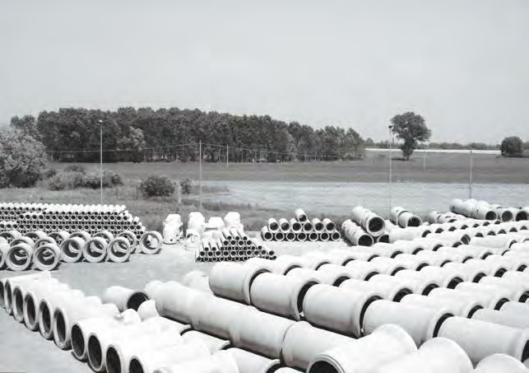

[Area.avi - Google Drev](https://drive.google.com/file/d/0B2aRABOiZUypMjdncy16UmQ3Z0k/view?resourcekey=0-_7kGGks1TS_yxib-WIK3Ew)



# Plant Key Equipment Concrete Mixing Equipment, Cement and Aggregate Storage

The storage station consists of 5 silos holding 450 Tons of aggregate in four granulometric grades, and 2 cement silos, 70 tons each.

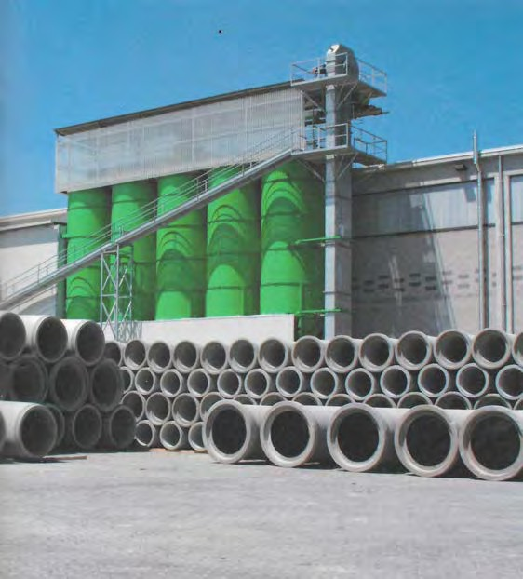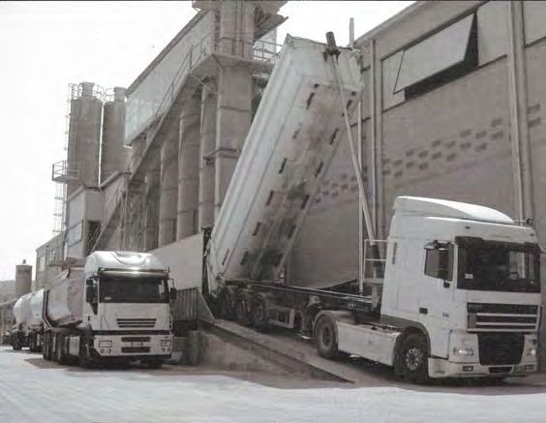

An excellent homogeneity of the mixture is ensured by a 2500 liter planetary mixer, where the moisture controls and ensures the W/C design ratio to be kept in a very tight tolerance.

The aggregates are dumped into a ground hopper and transported to the correct silo by bucket elevator.

The aggregates are weighed by a traveling weigh hopper.

The aggregates are delivered to the mixer with a skip hoist.



# Plant Key Equipment

**Fully Automated Plant 12’’/300mm – 48’’/1200mm**

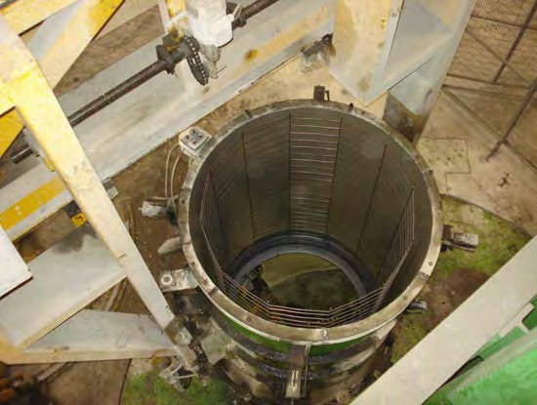**PACKERHEAD (RADIAL PRESS) MANUFACTURING BFS SOUVERAEN 1230**

During its upward stroke, the set radial compression

is steadily under control and guaranteed, so as to reach a finished product with high qualities as follows:

* Minimum inner roughness
* No taper on the ID
* Gasket joints turned during manufacturing
* Very high strength
* 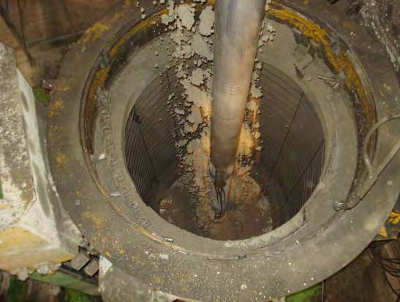Counter rotation of the rollerhead ensures no twists to the cage reinforcement, and high radial compression values.

**TWO JACKETS OPERATE IN TANDEM**

One is used for the casting, the other for the automated positioning in the curing area / demolding. In this way the casting and the positioning are 2 automated and parallel processes.

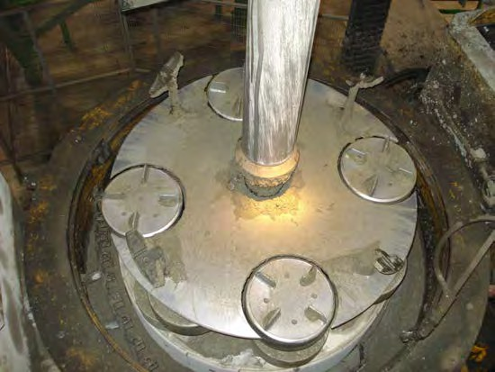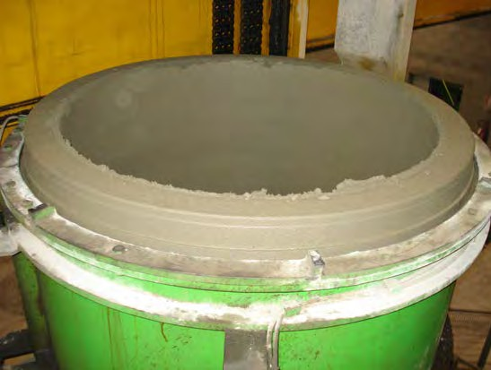



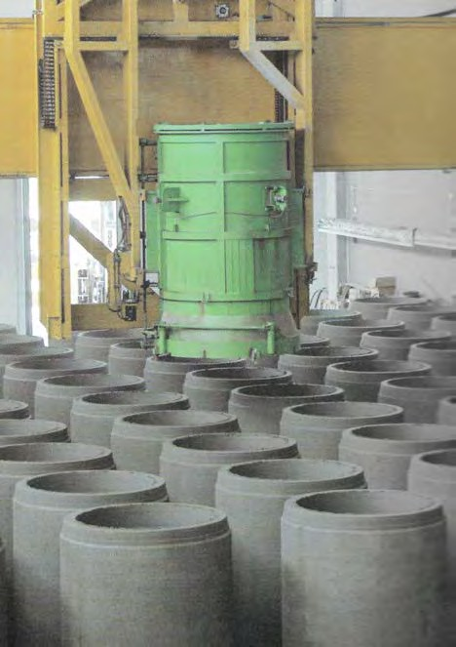**AUTOMATED POSITIONING IN THE CURING AREA, AND DEMOLDING**

The positioning in the curing area followed by the demolding is an automated process managed by the automated robotic system.

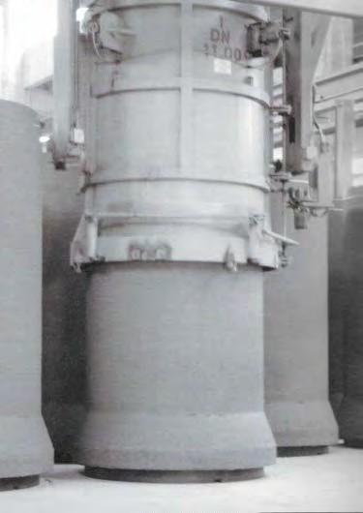

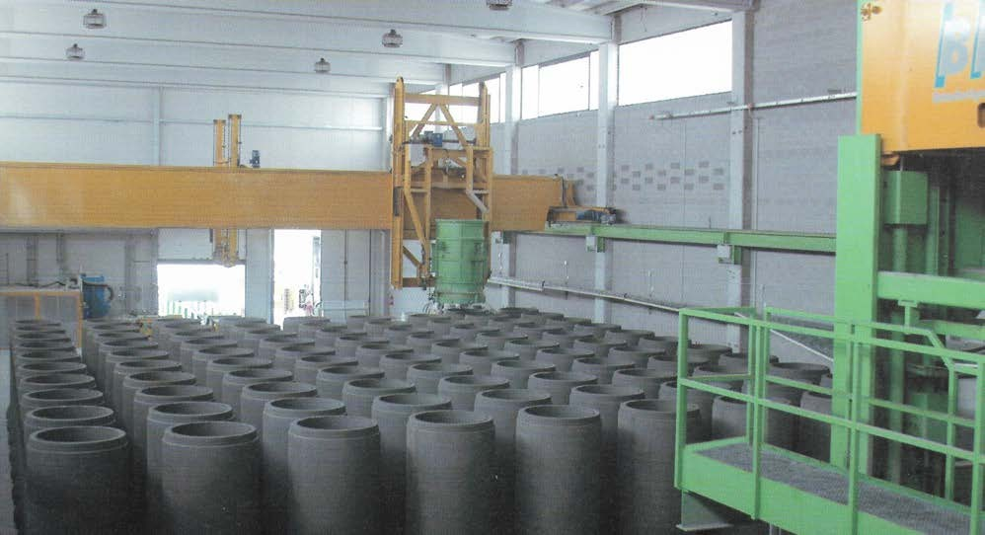



**AUTOMATED OFF BEARING**

After the curing, the pipe is moved to a station to automatically remove the base pallet. The pipe is then rotated 90° degrees and placed on a transfer cart and moved outside the plant into the storage yard.

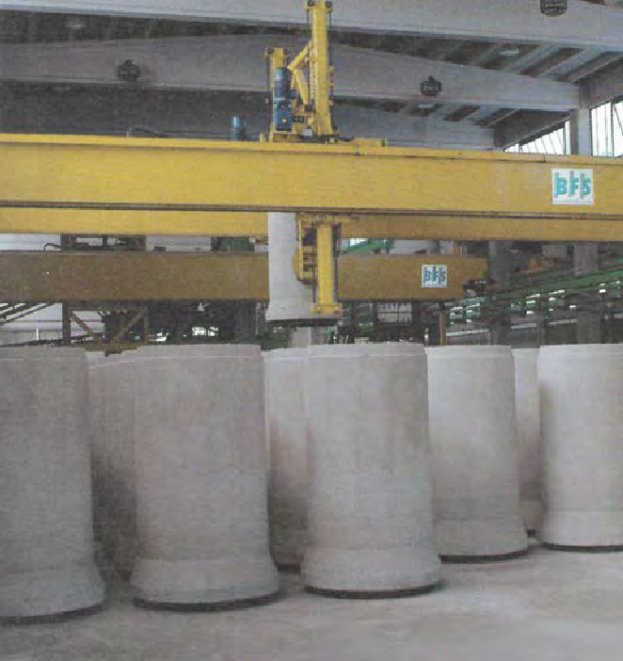

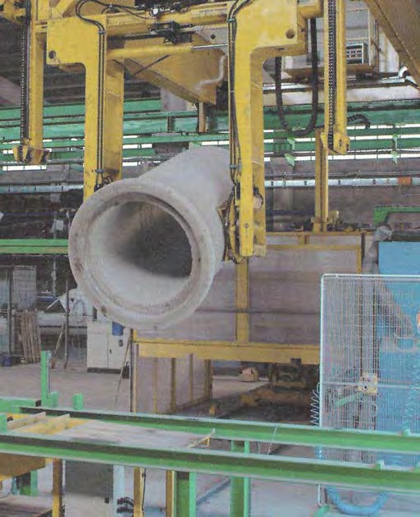

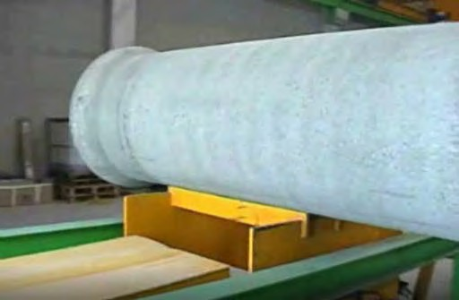

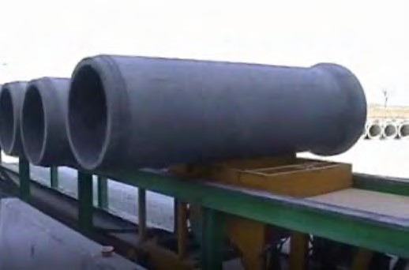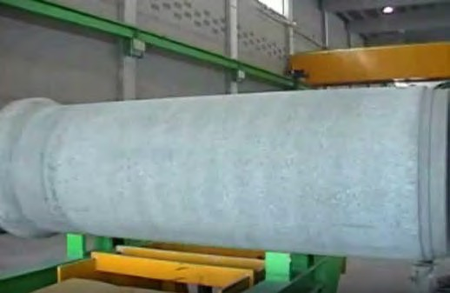



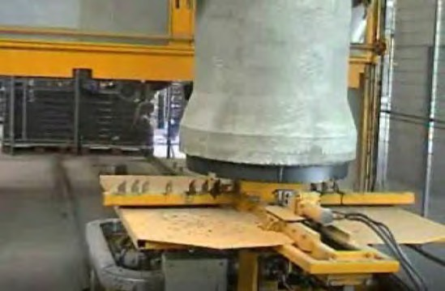**AUTOMATED BASE RING HANDLING**

After the automated process of depalletizing, the base rings are automatically cleaned, oiled, and moved to the production line. There the reinforcing cage is placed on the base ring.

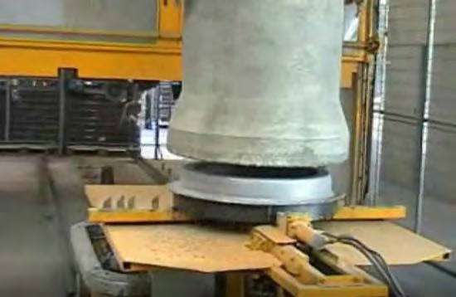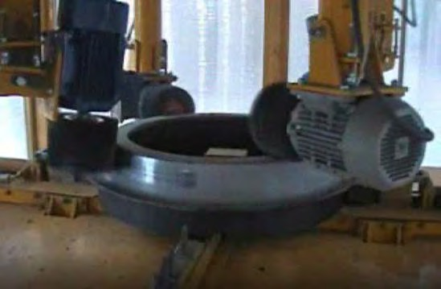

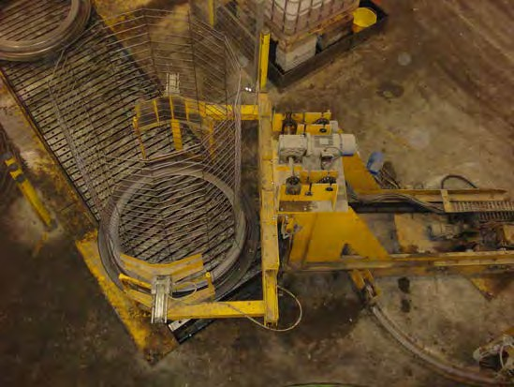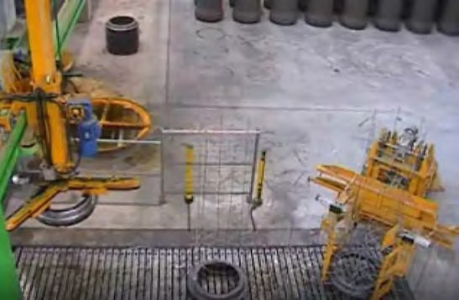



# Plant Key Equipment Automated Cage Welding System

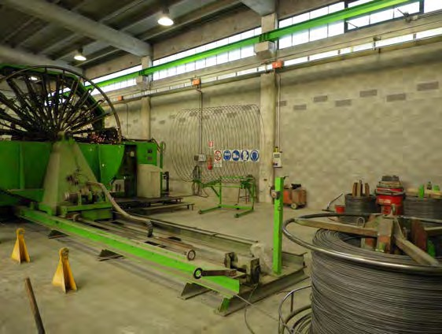The cages are manufactured by automated MBK welding machines, utilizing precut one-length longitudinals and continuous welded spirals. In the bell area the cage is automatically expanded.

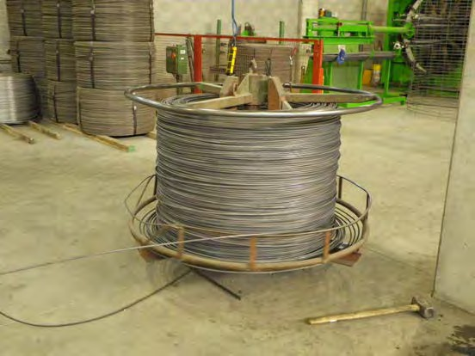

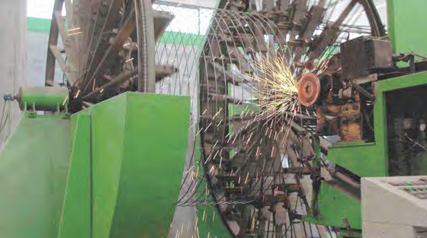

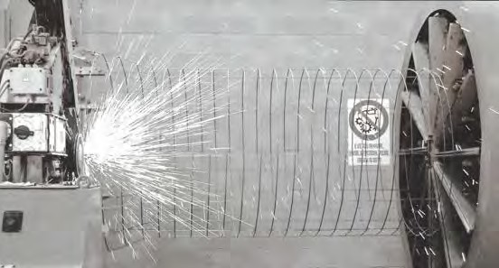

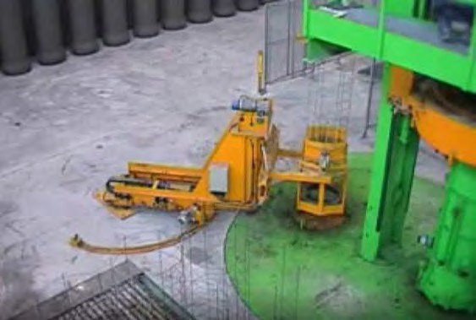

* Automated MBK Cage machine DN 300 (12’’) – DN 1200 (48’’)
* Automated MBK Cage machine DN 1400 (54’’) – DN 3600 (12ft)



# Plant Key Equipment

**Semi-automated Plant for Pipes up to DN3600 (12ft’), and Box Culvert**

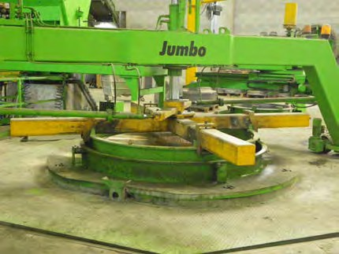The BFS production station features two stations for the dry cast production of pipes up to 3600mm (12ft) and other geometries like box culvert, vaults, and tanks.

The Dual station allows simultaneous production of two different products which provides the highest level of efficiency and flexibility.

The Dual station design maximizes the time the beltfeeder is running and filling molds and keeps the manhours per ton metric at the lowest level.

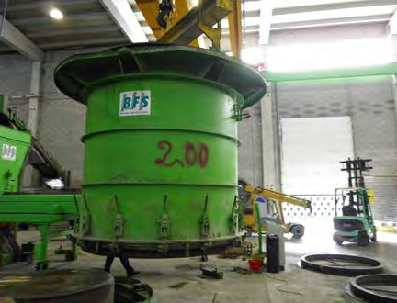

The size of the Vibration table is 2500 x 2500 mm

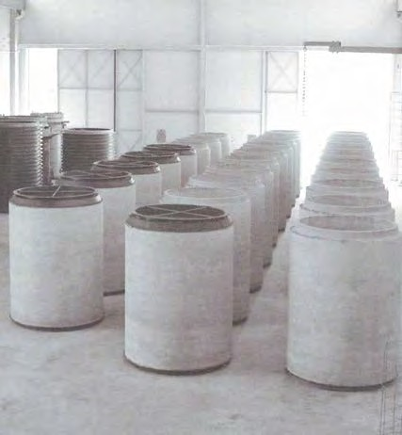

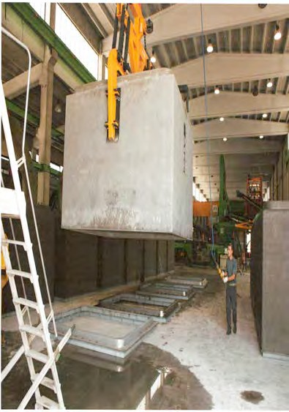



# Plant Key Equipment Mold Equipment

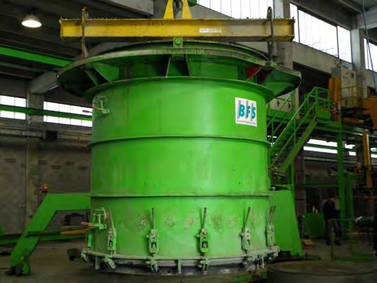Please see the Mold List for a detailed list of mold equipment for pipes and box culvert

* + Pipes DN 300 (12’’) to DN 2000 (80’’)
  + Box culvert DN 3000 x DN 2500 mm

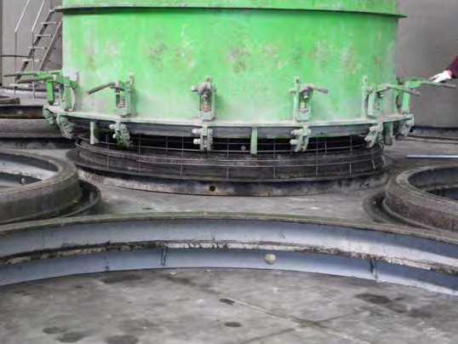

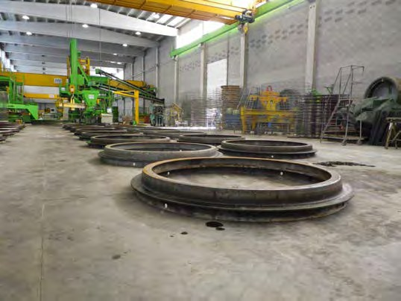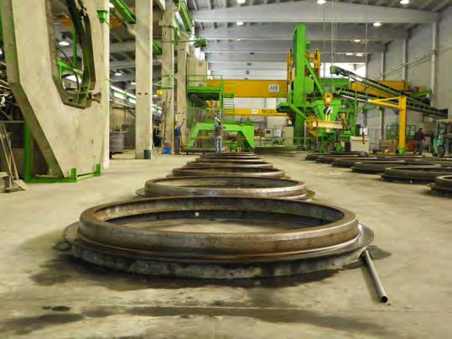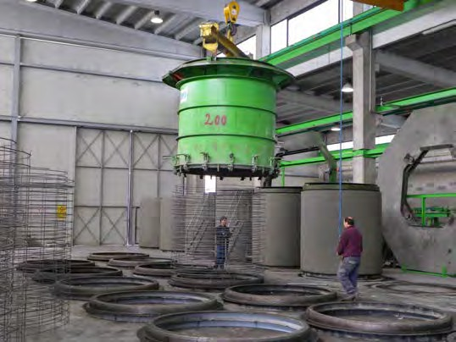



# Plant Key Equipment Production Support and Testing



### Forklifts:

2 – Linde 8 Ton forklifts with fork positioners 1 – Linde 8 Ton forklift with tilting clam

1 – Svetruck 12 Ton forklift

1 – Svetruck 13.6 Ton forklift with side tilting clamp

### Handling:

1 – Demag jib crane for handling flanges and rings 3 – Probst handling devices



1 – Hydraulic tilting table for Box Culverts / large pipes

### Testing:

1 – Controls brand D-Load tester DN 300 (12’’) – DN 2200 (84’’)

Joint plugs and hydraulic tester for pipe sizes DN 300 (12’’) – DN 1800 (72’’)

